Classification Importer tool – User Guide

# Introduction

This simple command line tool can be used to import classifications into DAM in bulk, using Excel CSV file. The CSV that is used as import file is using ; as separator.

This is what the tool can do:

* Create new classification objects in DAM or update existing classifications
* For each new classification you’re importing you will be able to define
  + Parent classification namepath
  + New Classification name
  + Identifier
  + Label in default language (English)
  + A number of fields and their values for classification object – intended to support classifications that have dependencies configured

# How to use it

## Step 1: Clone and build the tool

Clone the repository and build it. The rest of this guide assumes executable is generated and instructions are aligned with that.

## Step 2: Configuration

**Configure environment details** to define where you’re importing classifications to and **authentication details** for this environment. Open ClassificationsIngestion.dll.config file in text editor (notepad++ for example).

All important lines in this file are given in format key=”some key” value=”value to be provided”. You need to populate value attribute with appropriate value under quotes.

* In line where key=”registration”, enter value for registration under value=””. Registration/domain of destination environment or in other word Aprimo instance name from URL
* Provide token value in the next line. Token for this application needs to be Base64 encoded value of *username:usertoken*, where user token can be generated if not generated already, instructions are given here: [https://developers.aprimo.com/marketing-operations/rest-api/authorization/](https://developers.aprimo.com/marketing-operations/rest-api/authorization/-). You can use <https://www.base64encode.org/> site to encode your token and username as needed.
* Provide clientId value. Generate client if not generated already, instructions are given here: <https://developers.aprimo.com/marketing-operations/rest-api/authorization/>
* Then in lines for TokenEndpoint and RESTEndpoint replace word “customer” with registration (instance name)
* Save config file with these changes.
* Note that if at a later time you need to run import into another environment, you will need to change environment details within this same config file.

This is how config file might look filled out:

## Step 3: Prepare import file

Import file for the tool is CSV that is separated by ;

You have a template for this file in folder that contains the tool (Example Import Spreadsheet.xlsx). Use this to populate data that you want to import.

* to fill it, you can first split content into columns (go to Data in Menu, and use Text to Columns options)
* first 4 columns (representing basic classification details) are mandatory (meaning column header is expected), though the values might be left empty!
* After these 4 columns, you can provide multiple columns that represent classification fields (header column would contain field name), that would allow you to provide field data for classification you're importing. This can be used for example if you want to provide dependent classification data (for configuring dependencies between taxonomy). Use ### as separator, if field data contains multiple values, and use namepath if field in Classification List field type
* Once you populate the file, before importing, make sure to save it as CSV, with ; as separator and not comma! You can do find/replace in notepad++ for your CSV to achieve this. Note: for this to work properly, you should not use , or ; in values for your columns (avoid using these characters in classification labels).
* Note where you’ve saved prepared file, as you will need file path to run the tool

Here’s how your populated file might look like in Excel:

## Step 4: Run the tool

You can run the tool by double clicking on ClassificationsIngestion.exe file. You will see only one line/question in the console:

You need to provide the path to the prepared import file from your computer. You can copy that path by navigating to the file, holding shift, right-clicking to get menu options and choosing “Copy as path”.

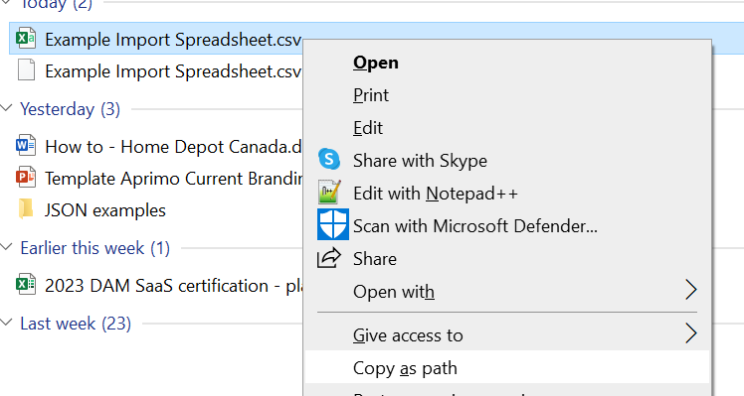

You can then paste this path into console just by right-clicking into it. Make sure to remove quotes around the path before you continue with execution, so the path should look like this:

Then hit enter on your keyboard to let the tool start importing.

The tool will log what it does, hopefully you’ll get successful messages like these:

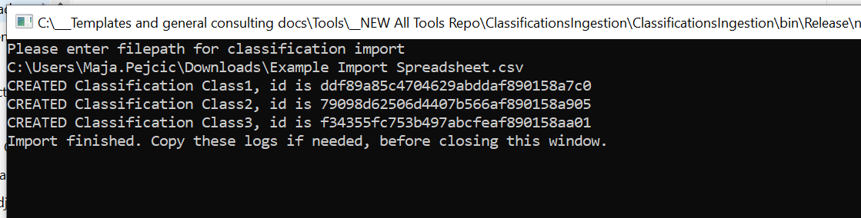

If errors occur, that too will be logged.